The Union

This print depicts four Philadelphia monuments to great Union generals of the Civil War: Generals Ulysses S. Grant, George B. McClellan, John F. Reynolds, and George G. Meade. None of the four monuments receives sufficient attention or respect in its current location. We propose to honor the generals, the City, and the Union by uniting the monuments and positioning them on the vacant portions of Eakins Oval at the top of the Benjamin Franklin Parkway.

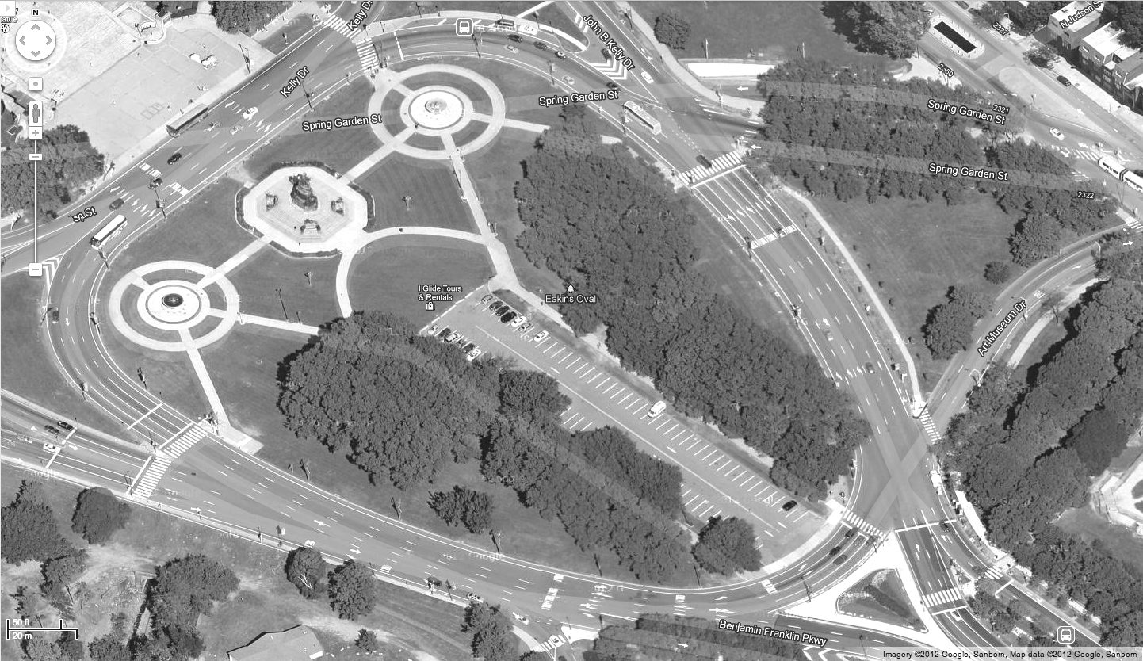
Grant

Meade

McClellan

Reynolds

It seems particularly appropriate for the monuments to be displayed together in the heart of Philadelphia’s current art and cultural district. The four sculptures complement the design and history of the Parkway and the Philadelphia Museum of Art. On Eakins Oval each general could be featured prominently, free of clutter and distraction. The addition of the monuments on Eakins Oval would also encourage foot traffic between the Museum of Art, the Rodin Museum, and the Barnes Collection. United, the collection of monuments would surely become a treasured destination.

- Republican
General Ulysses S. Grant was one of the most successful generals of the Civil War. He won key battles at Vicksburg and Chattanooga. After these successes, President Abraham Lincoln made him Lieutenant General and the supreme commander of the Union Army. Grant carried out the master strategy of splitting the South in two, leading eventually to the rebels’ surrender at Appomattox. Later, he served two terms as President of the United States.

The monument to Grant is by Daniel Chester French and Edward C. Potter. French is best known for his statue of Abraham Lincoln in the Lincoln Memorial. Potter, who designed the horse in this sculpture, was French’s former student.

President William McKinley was present among the throngs which attended the unveiling of the monument to Grant in 1897. At the time, the monument was located at the intersection of Fountain Green Drive and East River Drive. The latter road is now known as Kelly Drive. It was once suitable for a slow Sunday ride that might include a stop to admire the monument. Now, few travelers take the time as they shoot past, aiming to catch the green light.

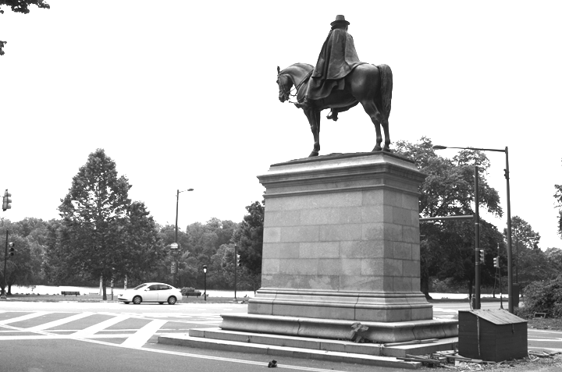
Alert passersby or those who pause at the light might enjoy the monument from a distance, but nobody gets a close view of General Grant without braving a dangerous crossing. Even if it were not a busy traffic zone, the area around the monument is uninviting. Thick white and yellow hashmarks are painted in the road around the pedestal to discourage cars from parking or making u-turns. Someone built a green utility shed behind the monument, probably to store police barriers for the frequent closings of Kelly Drive for boat races and other events. On an average day, a visitor can find leftover blue and yellow police barriers leaning against the pedestal or lying on the ground.

- Democrat
General George B. McClellan was born in Philadelphia in 1826. His father was one of the founders of Jefferson Medical College. After the Union army was defeated at the First Battle of Bull Run in July 1861, McClellan saved the nation’s morale by constructing the massive fighting force known as the Army of the Potomac.

McClellan was slow to use the Army of the Potomac, but in June 1862 he closed within miles of the rebel capitol, Richmond, Virginia. Although he was the victorious general of the Seven Days Battles outside Richmond, he ordered a retreat in the wake of the unprecedented bloodshed. In September 1862, at the Battle of Antietam in Maryland, McClellan stopped the rebels’ first invasion of the North. Critics claimed McClellan never pushed his advantage against the rebels. It appears he was shy of committing his soldiers to certain slaughter, even if it cost him victory.

McClellan was one of the most popular generals among the troops. He ran against Lincoln in the presidential election of 1864 as the candidate of the Democratic Party while repudiating the party’s anti-war, conciliatory platform. After the war, from 1878 to 1881, he served as governor of New Jersey.
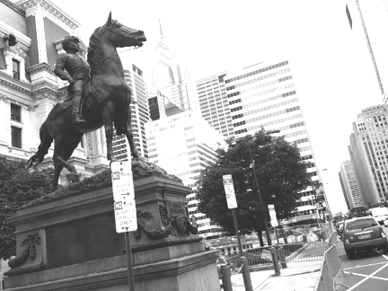
The monument to McClellan, created by Henry Jackson Ellicott, was placed in front of Philadelphia’s City Hall in 1894. In the present day, the monument is typically surrounded by parked cars, street signs, and barriers. The horse’s bridle is missing two reins, and another rein, broken, dangles from McClellan’s hand.

- Martyr
General John F. Reynolds was born in Lancaster, Pennsylvania, in 1820. He was beloved by his troops and renowned for his battlefield heroics. On the first day of the Battle of Gettysburg, July 1, 1863, he was shot and killed.

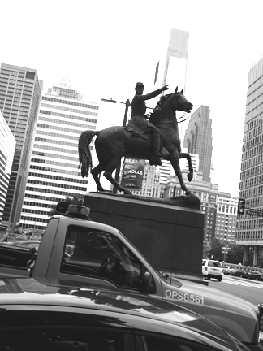
That morning one of Reynolds’ cavalry divisions, under the command of Brigadier General John Buford, encountered rebel infantry brigades concentrating near the town of Gettysburg. Reynolds rode into the fighting to organize the Union defenses. At the moment Reynolds shouted, “Forward men! For God’s sake, forward!” he was mortally wounded. Some believe he was shot by a rebel sniper. Regardless, his brave challenge to the rebel forces delayed their advance long enough to ensure that the Army of the Potomac would be able to fight on favorable ground.

John Rogers created this monument in 1884. Rogers was a popular artist at the time because of his mass-produced small genre sculptures, known as “Rogers Groups.” The monument depicts Reynolds just before his death when he chose the field of battle and urged his men onward.

The statue of Reynolds is twinned with the statue of McClellan on the north plaza of City Hall. It suffers similarly from encroachment and neglect. The monument obstructs City Hall’s parking needs, and two reins are missing. Aesthetically, the monuments compete with City Hall’s ornate façade. Moving them would accentuate City Hall’s beauty.

- Hero
General George G. Meade commanded the Army of the Potomac at the Battle of Gettysburg, repelling the rebels’ final invasion of the North. At the battle he was an active frontline commander, repeatedly risking his own life to help fill holes in the Union lines. Thanks to his leadership, the rebels would never seriously threaten an invasion again.

Meade’s father was a Philadelphia merchant. After the war, Meade lived in the Rittenhouse Square area of Philadelphia at 19th Street and Delancey Place. He became the commissioner of Fairmount Park, which he planned and engineered. In 1872, Meade died from pneumonia complicated by his old war wounds. He is buried in Laurel Hill Cemetery.

The monument to Meade is by Alexander Milne Calder, who also sculpted the 250 statues that adorn City Hall, including the statue of William Penn at the very top. Calder was the father of Alexander Stirling Calder, who sculpted the statues at the Swann Memorial Fountain on the east end of the Benjamin Franklin Parkway. Calder was also the grandfather of the sculptor Alexander Calder, famous for his giant mobiles.

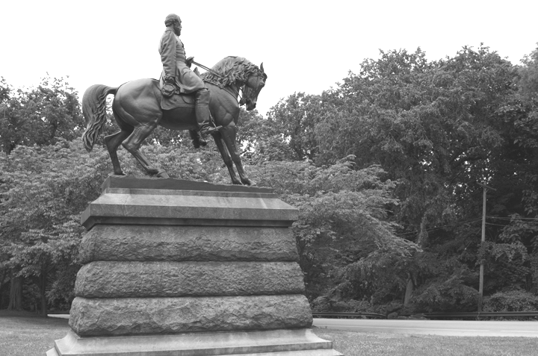
The statue of Meade, dedicated with great ceremony in 1887, features him helping to hold the Union line in the face of kamikaze rebel attacks. His steed is his favorite warhorse, Old Baldy, who was shot in the belly at Gettysburg. Miraculously, Old Baldy survived and lived for many years afterward. Old Baldy even accompanied Meade’s casket during its funeral procession through the streets of Philadelphia.

The Meade Society, led by Professor Anthony Waskie of Temple University, has been attempting to move the statue of General Meade to City Hall. They dislike the isolation of the statue in its current location in Fairmount Park behind Memorial Hall on Lansdowne Avenue. Once heavily traveled, Lansdowne Avenue now is rarely used. On a recent trip, the only other visitors to the monument to General Meade were two stray cats.

